**Name : Angha Varangaonkar TR : 1 Assignment No : 2**

**Q1 : Create some users:**

**1. Named “alex” with its home directory at /home/user1 and give password “pass1”**

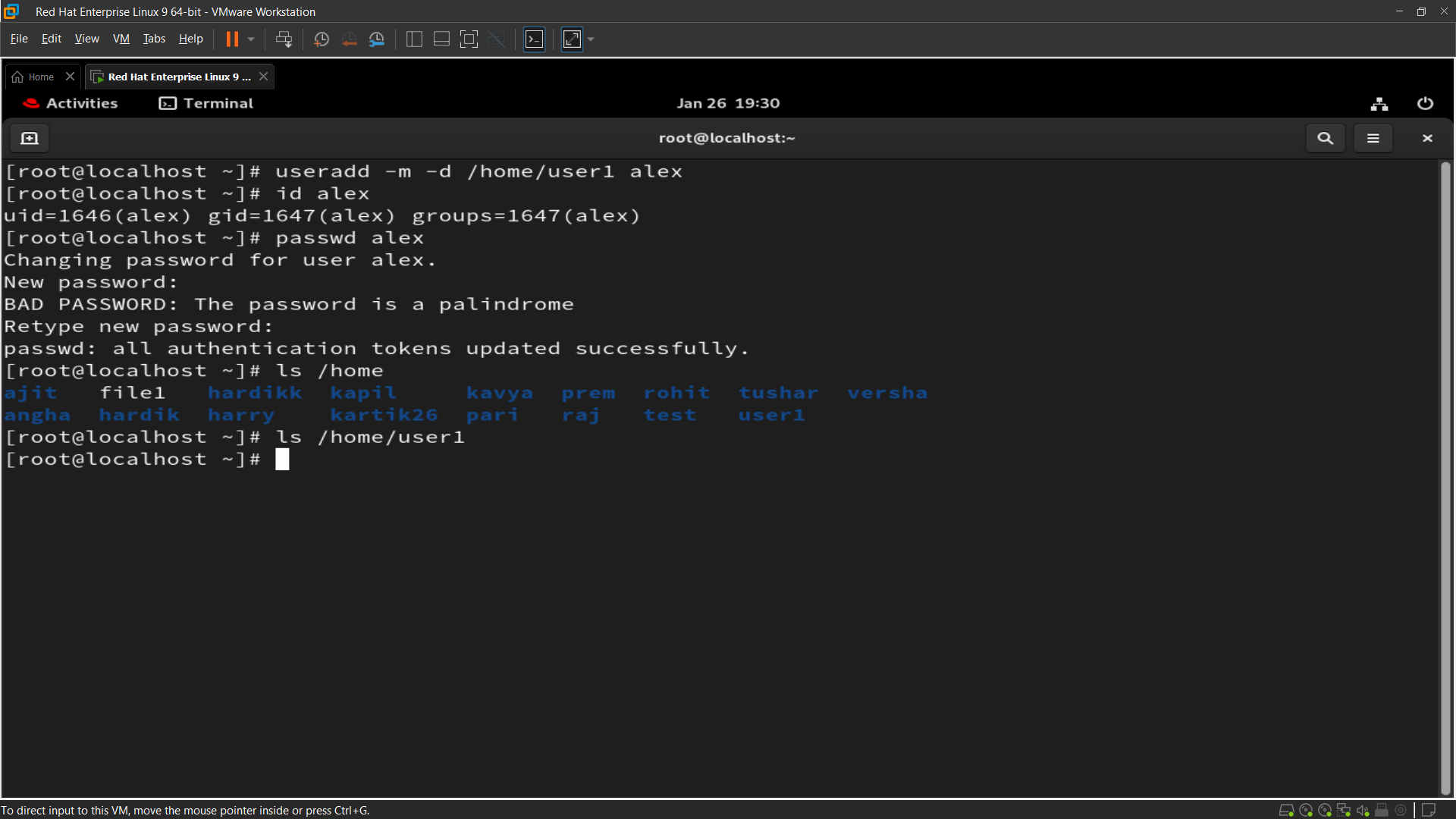

**2 Named “brew” with its home directory at /mnt/user2 and give password “pass2”.**

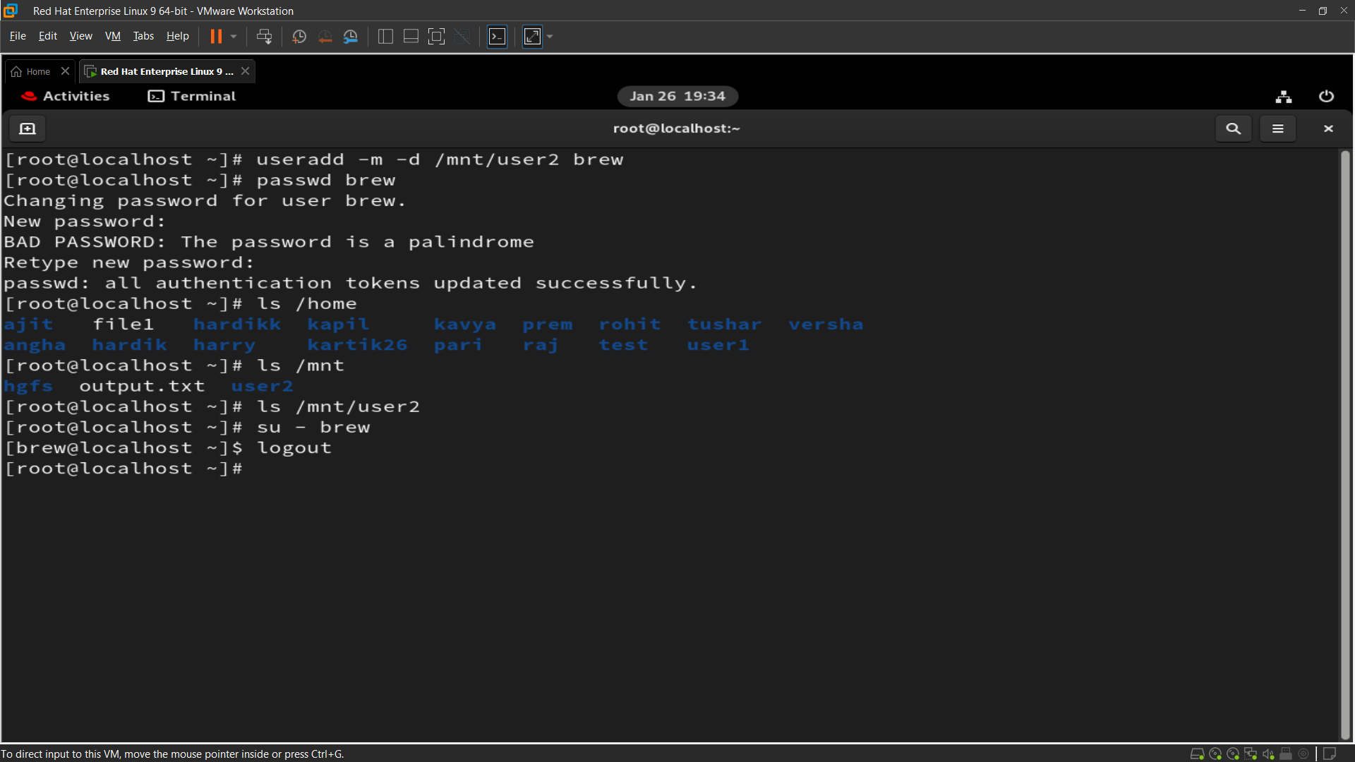

**3. Named “nora” without its home directory.**

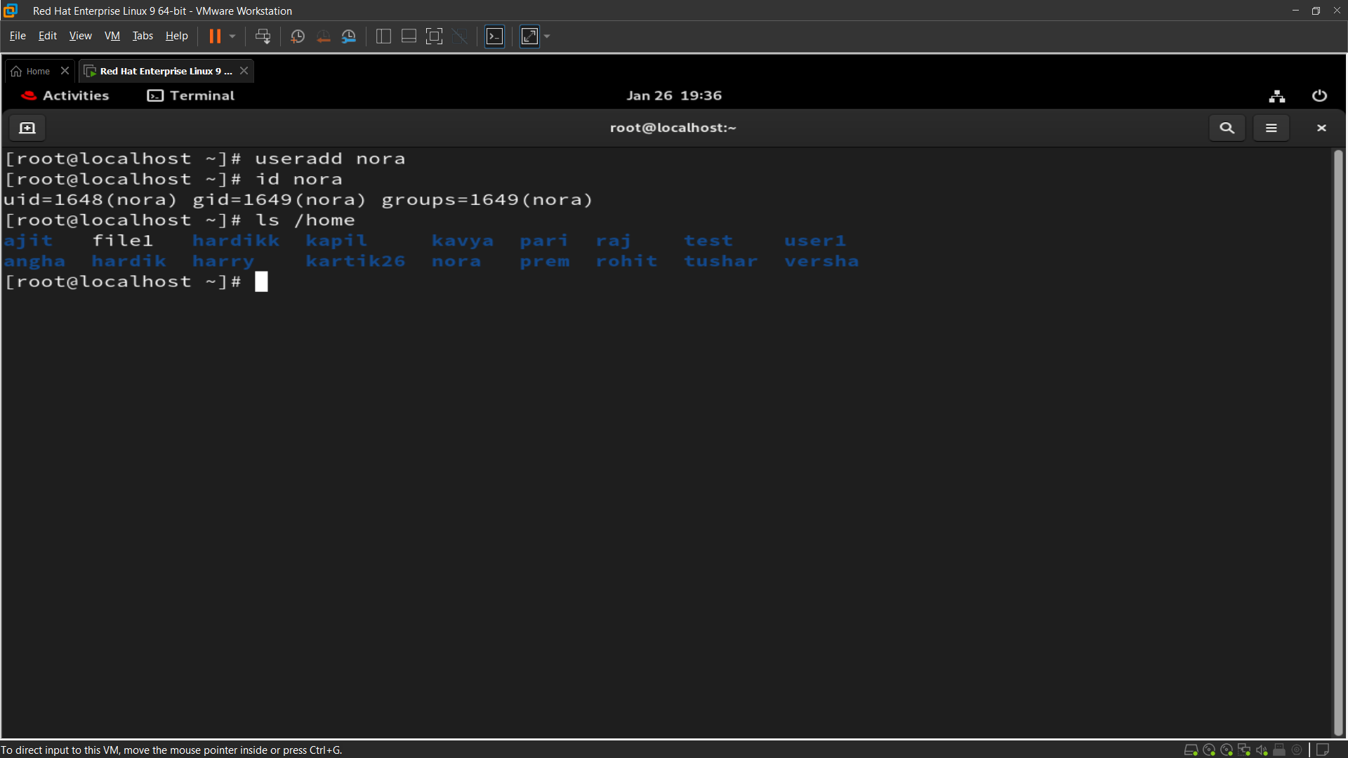

**4. Named “panny” with custom UID 2112, and assign password “pass-4”**

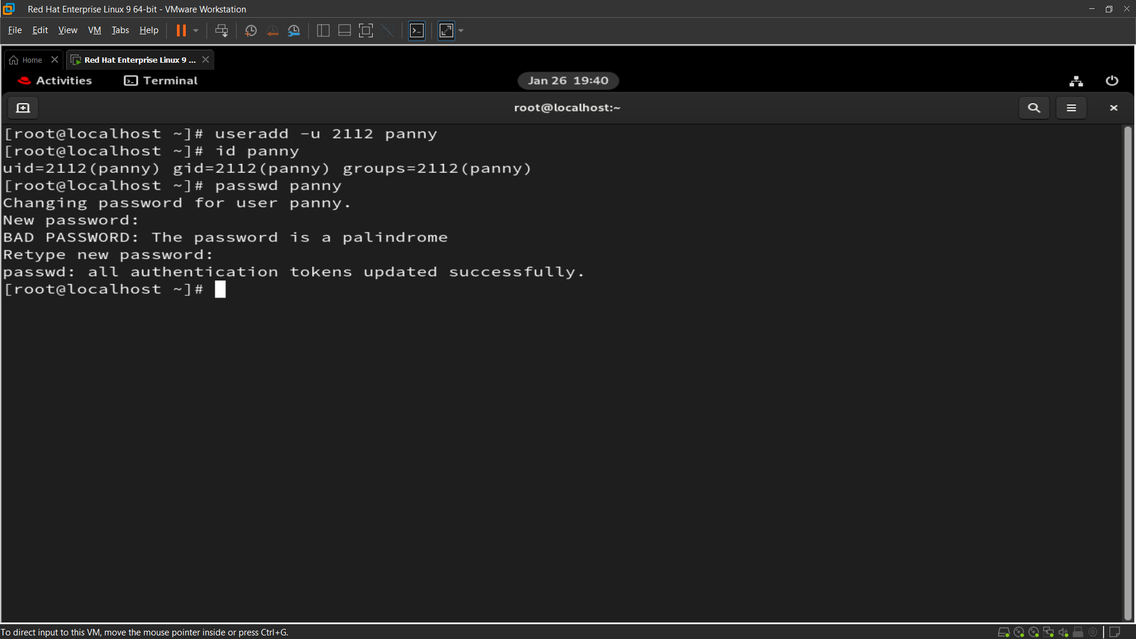

**5. Named 'texas' without using the useradd or adduser commands.**

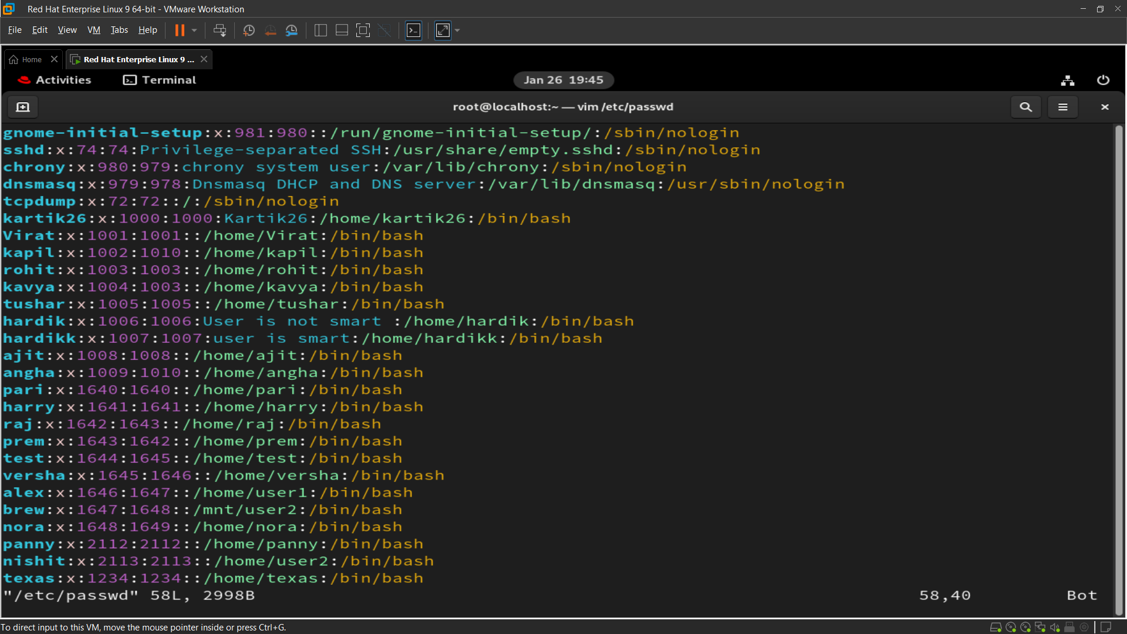

**Q2 : 2. Log in as user alex using the su and su - commands, and explain their differences**

**su alex: Switches user but retains the current environment.**

**su - alex: Switches user and starts a new shell session with alex's environment.**

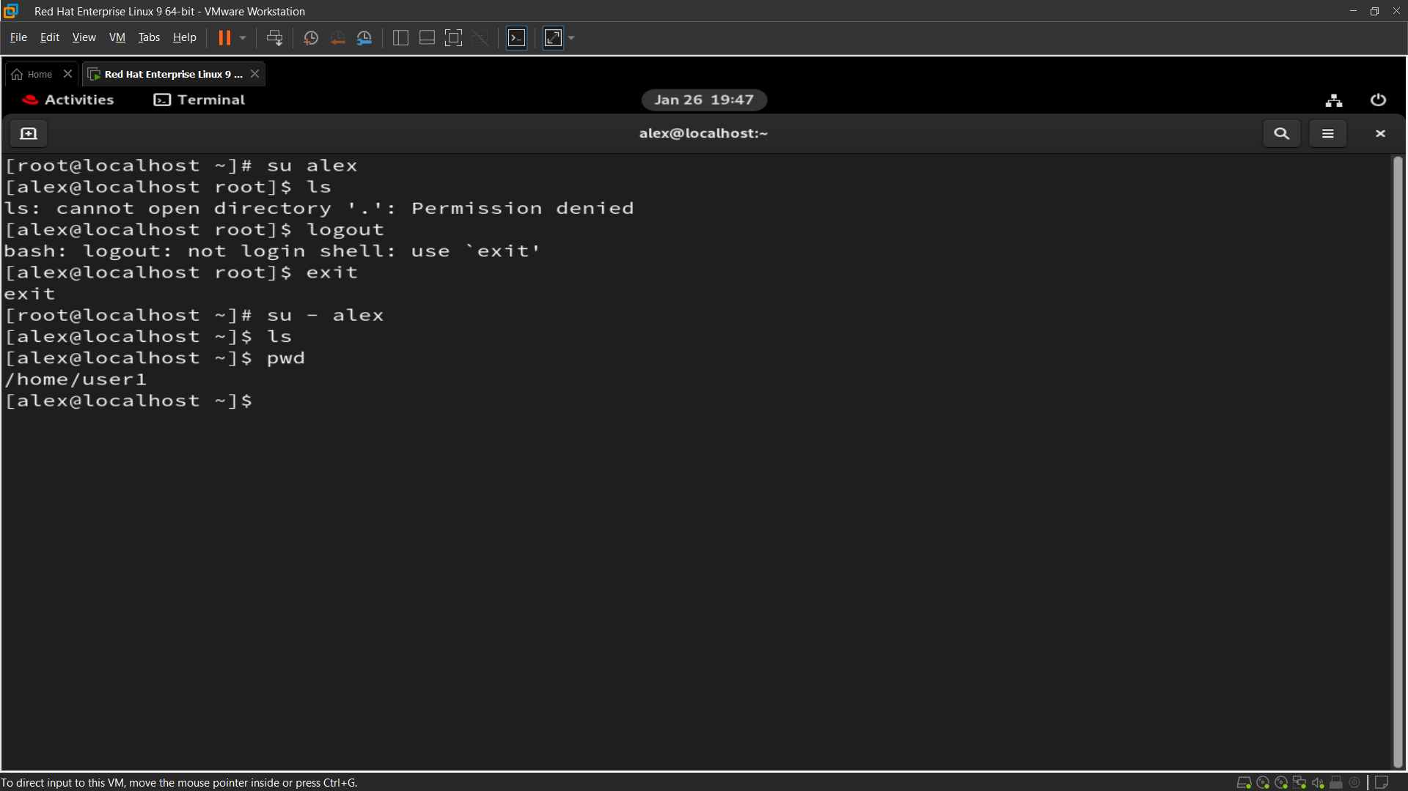

**Q3 : Set a password policy for all above users with the following requirements:**

**o The maximum password age should be 30 days, and the minimum password age should be 10 days.**

**o Set the password expiry date for all users to December 31, 2025.**

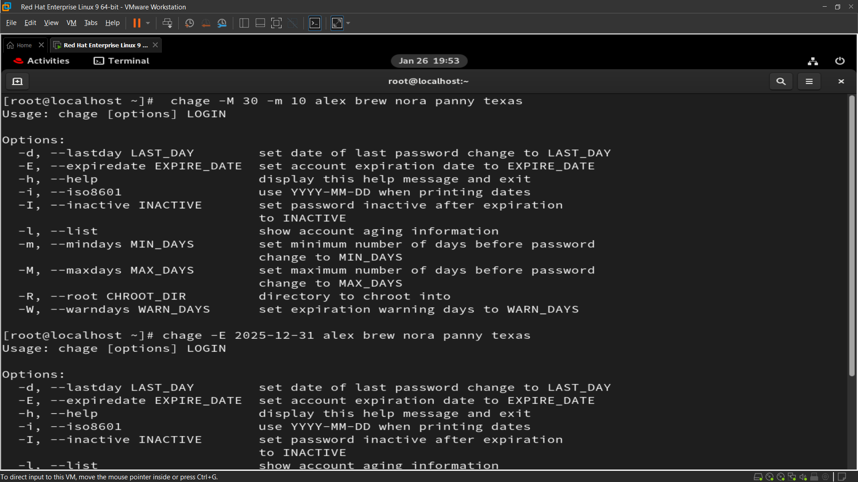

**Q4 : . Modify the user "alex":**

**● Add a comment: "I am alex" ● Change the UID to 2581 ● Change the shell to "nologin"**

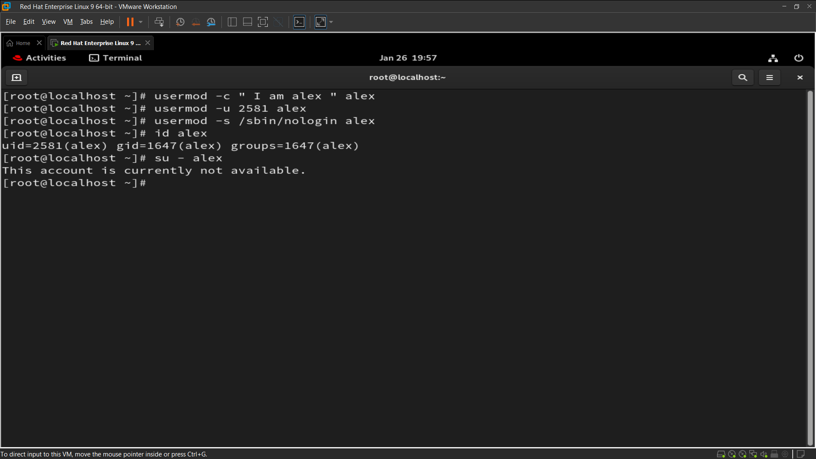

**Q5 : Create group with following configuration:**

**o Named “north” with secondary group member “alex” & “texas”.**

**o Named “south” with GID “2222”.**

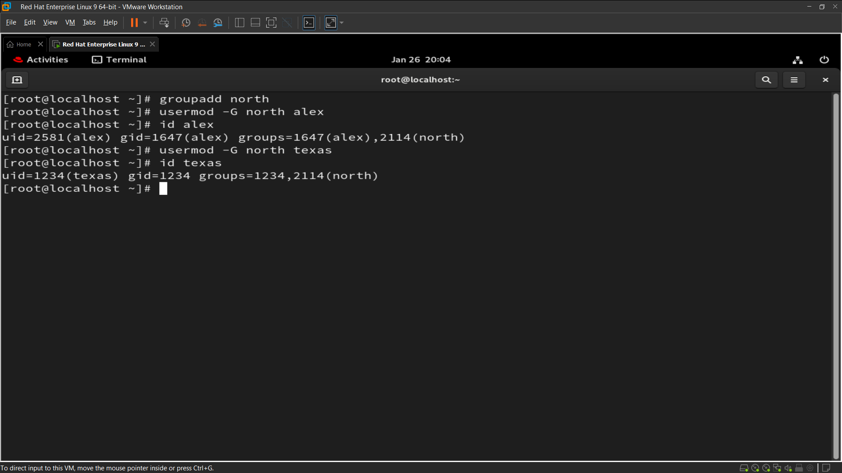

**Q6 : Grant user Alex administrative privileges through the wheel group so that Alex can add Panny to the admin group without requiring root access.**

**Image for Q6 :**

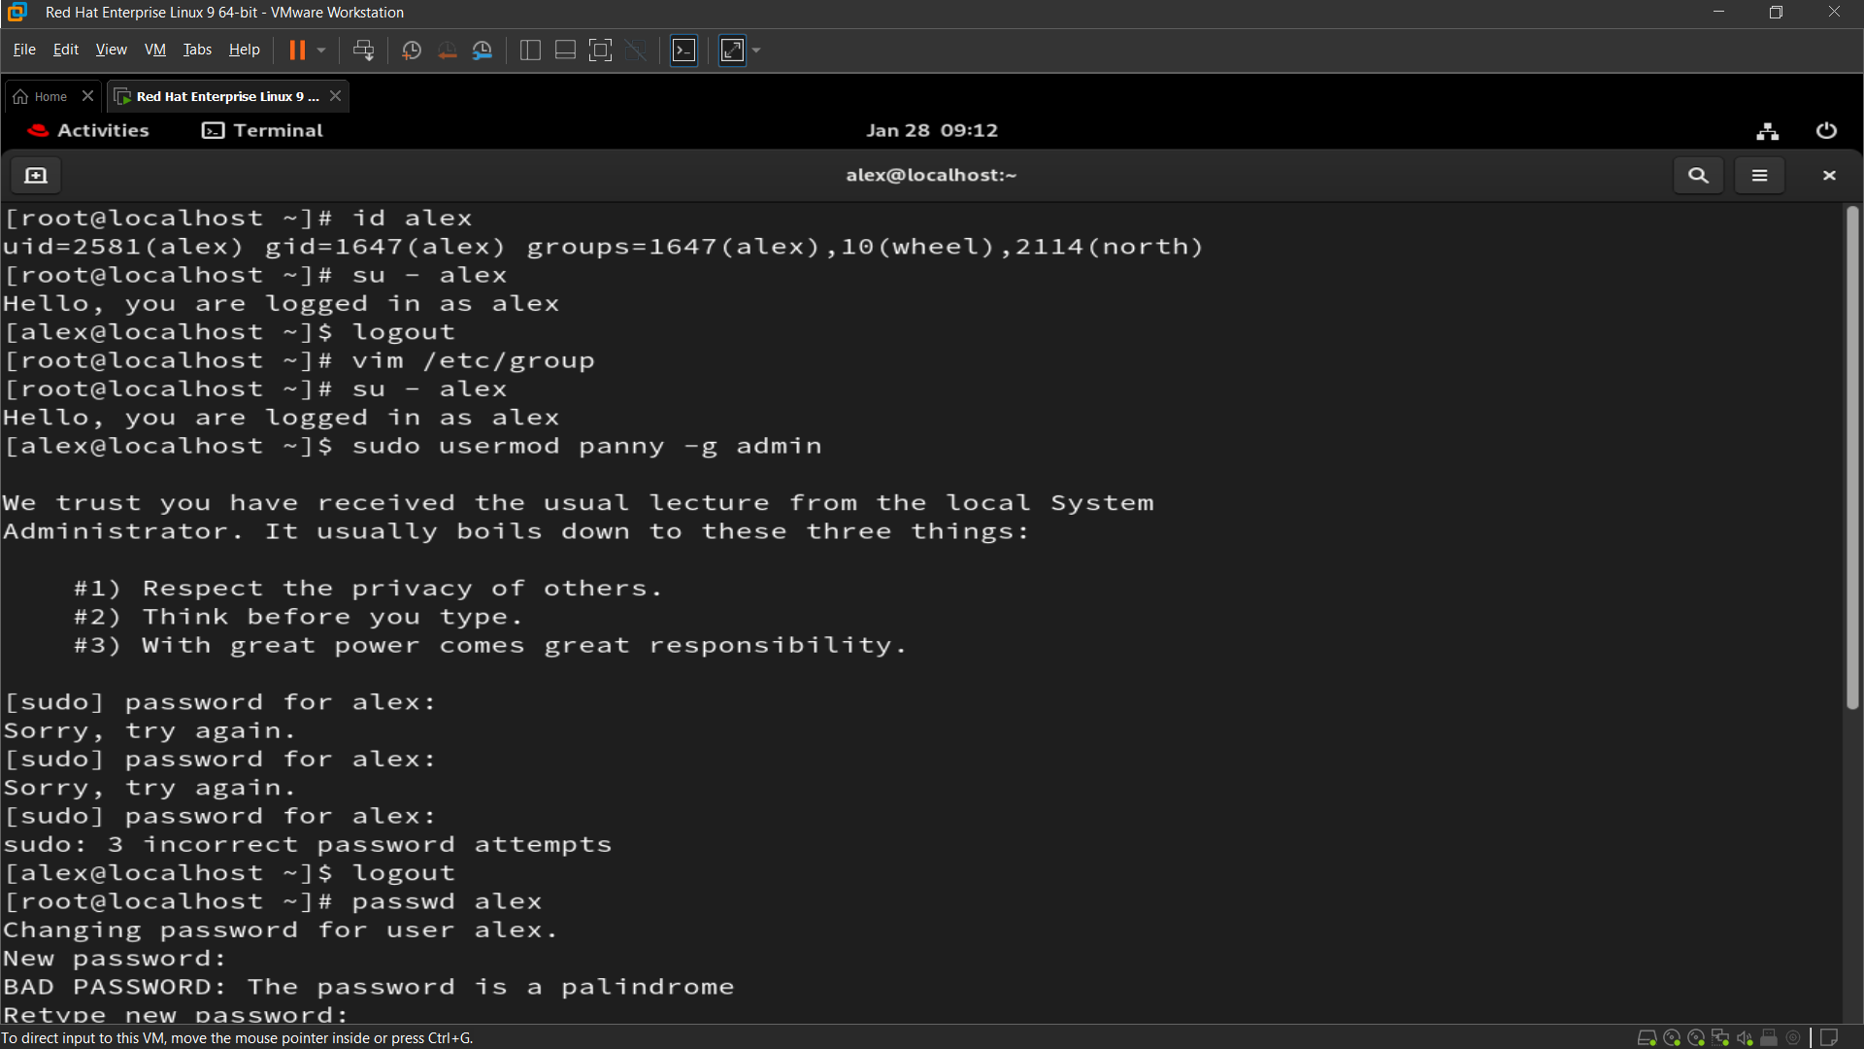

**Image for Q6 :**

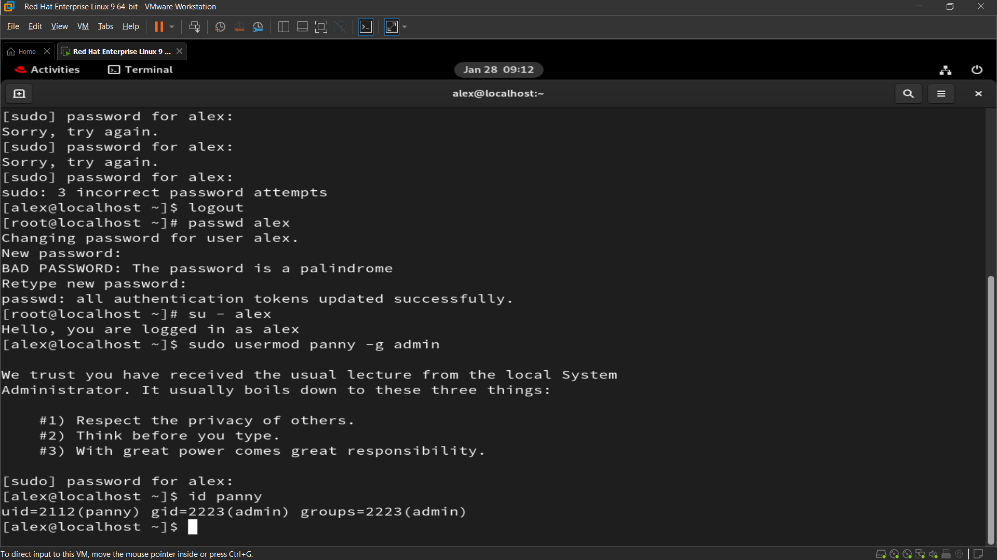

**Q7 : 7. Change the group name from “south” to “dakshin”.**

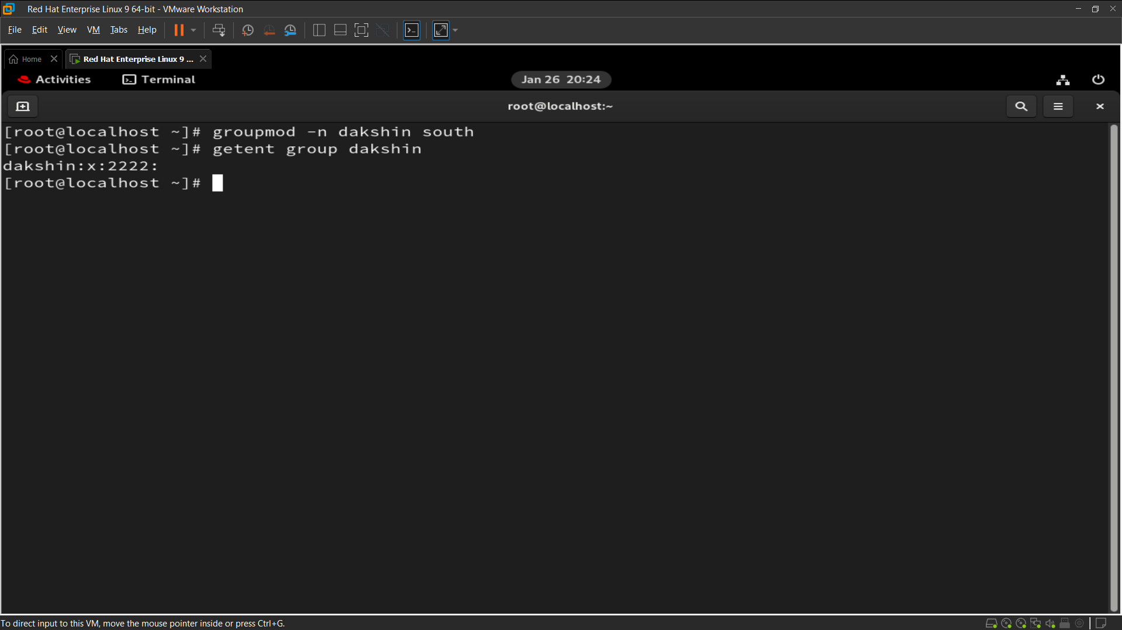

**Q8 : Create a system user named “ping” and check its UID**

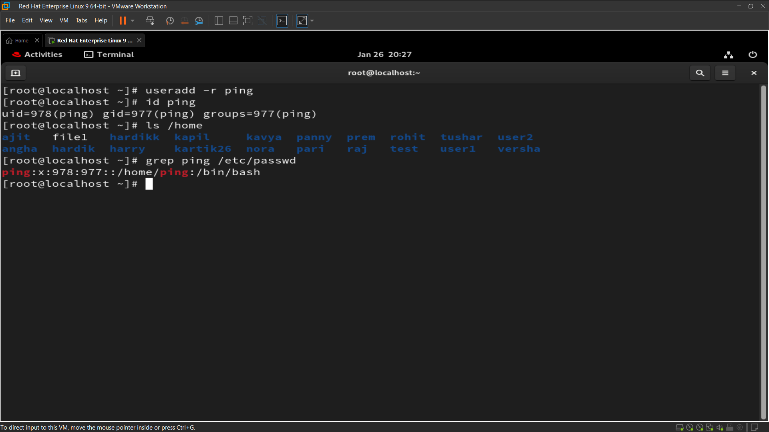

**Q9 : Create a group named goa with GID 11000. Set this group as the supplementary group for “brew”**

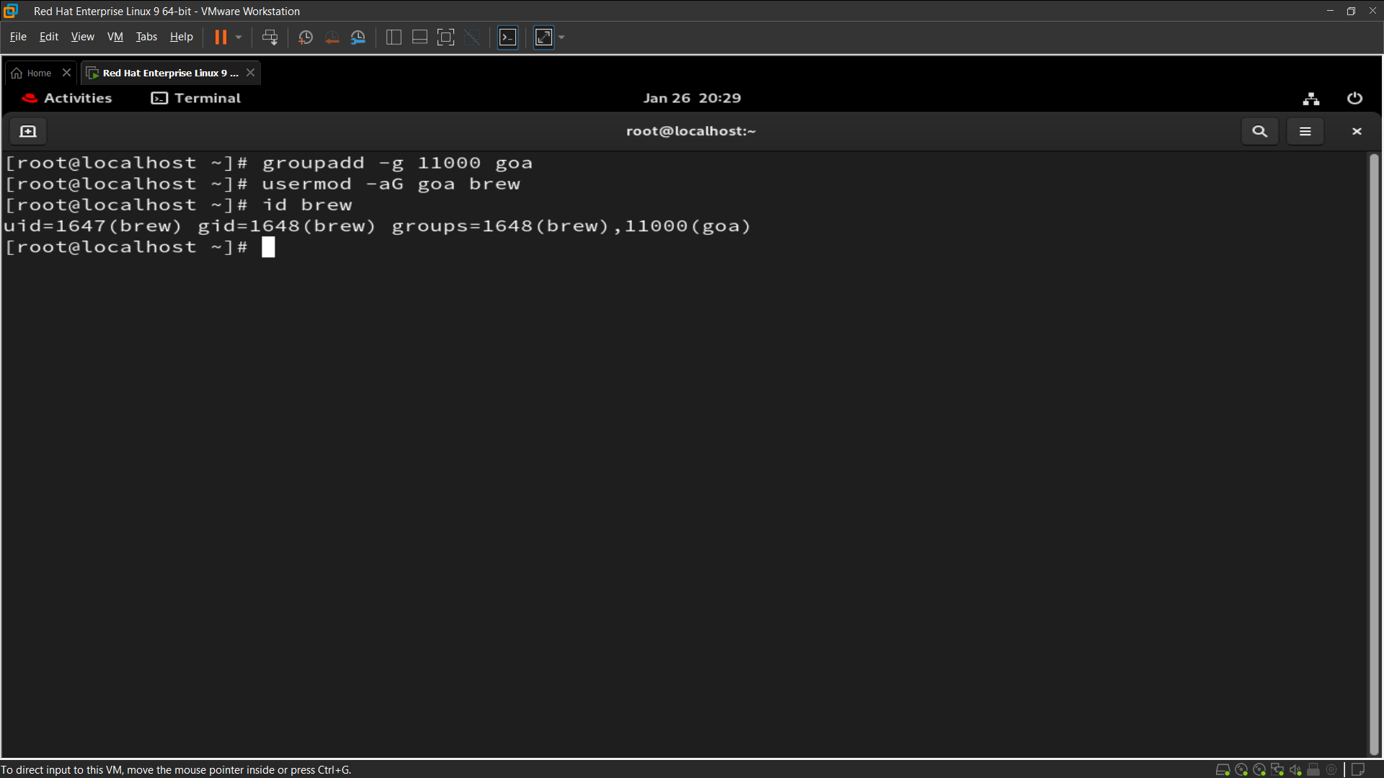

**Q10 : Create a group named “prod”. Then, create two users, user2 and user1, and set both the user’s primary group to prod.**

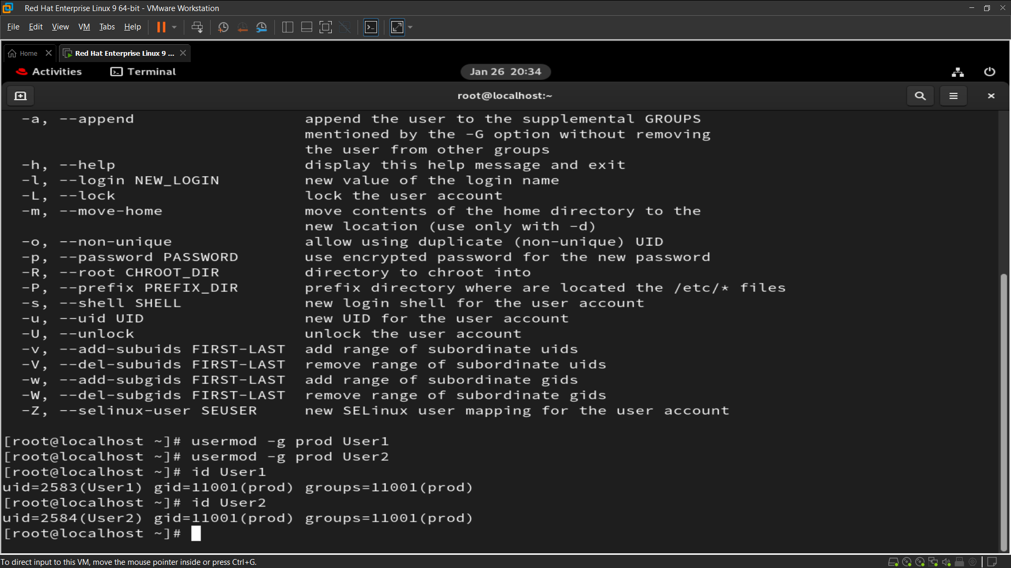

**Q11 : Change the password policy for the USER3 and USER4 accounts to expire on 2026-01-15.**

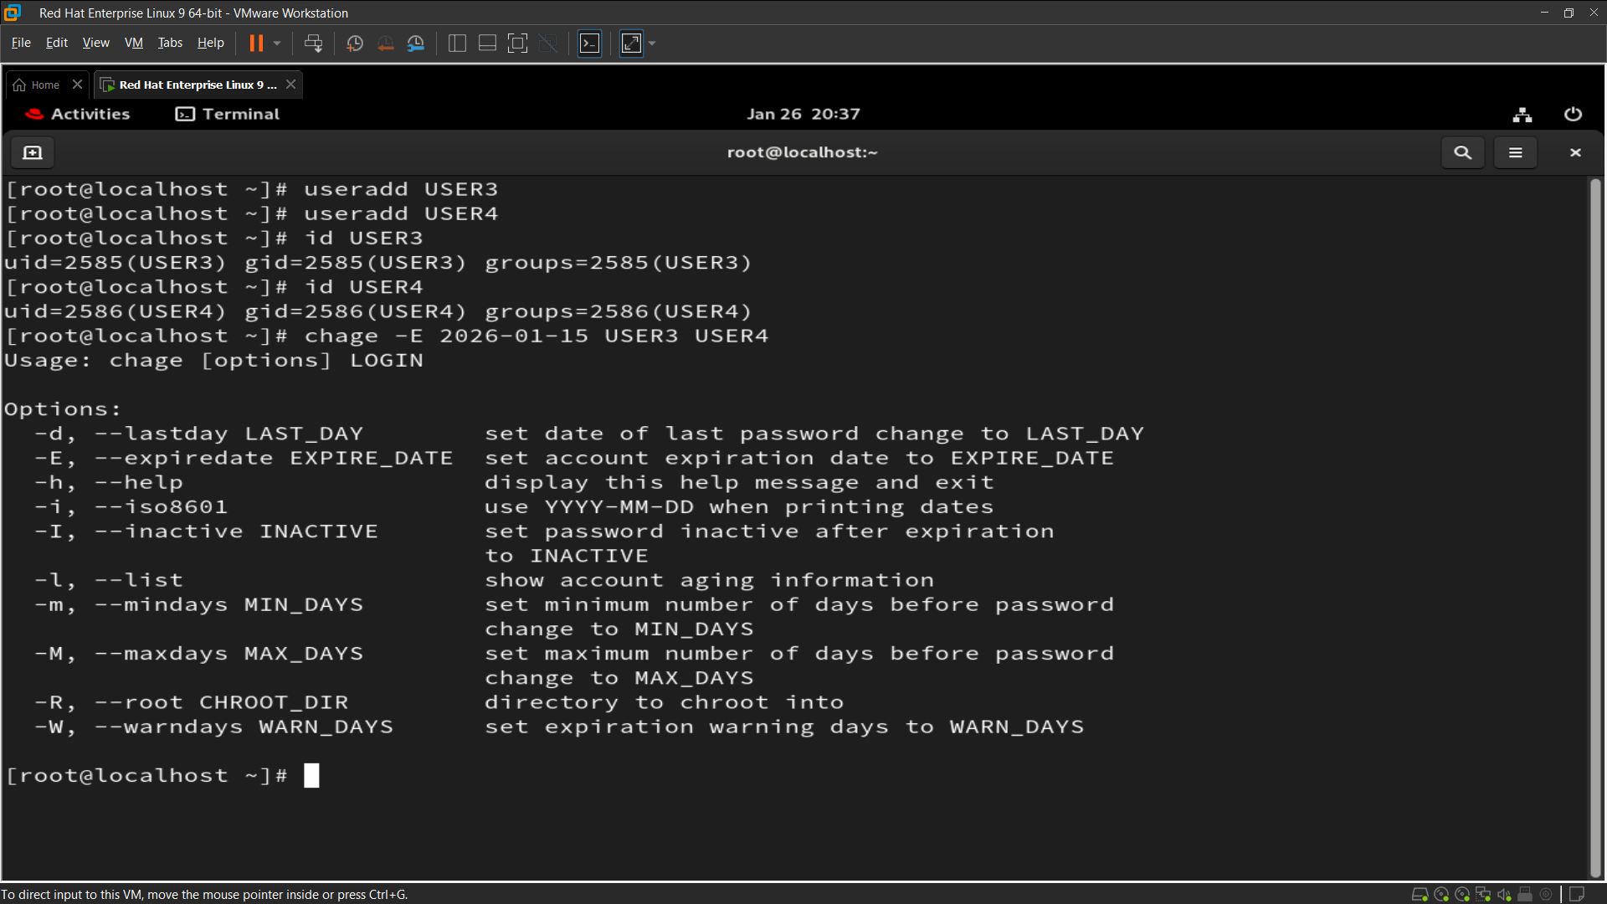

**Q12 : Configure administrative rights for all members of the Goa group to execute any command as any user.**

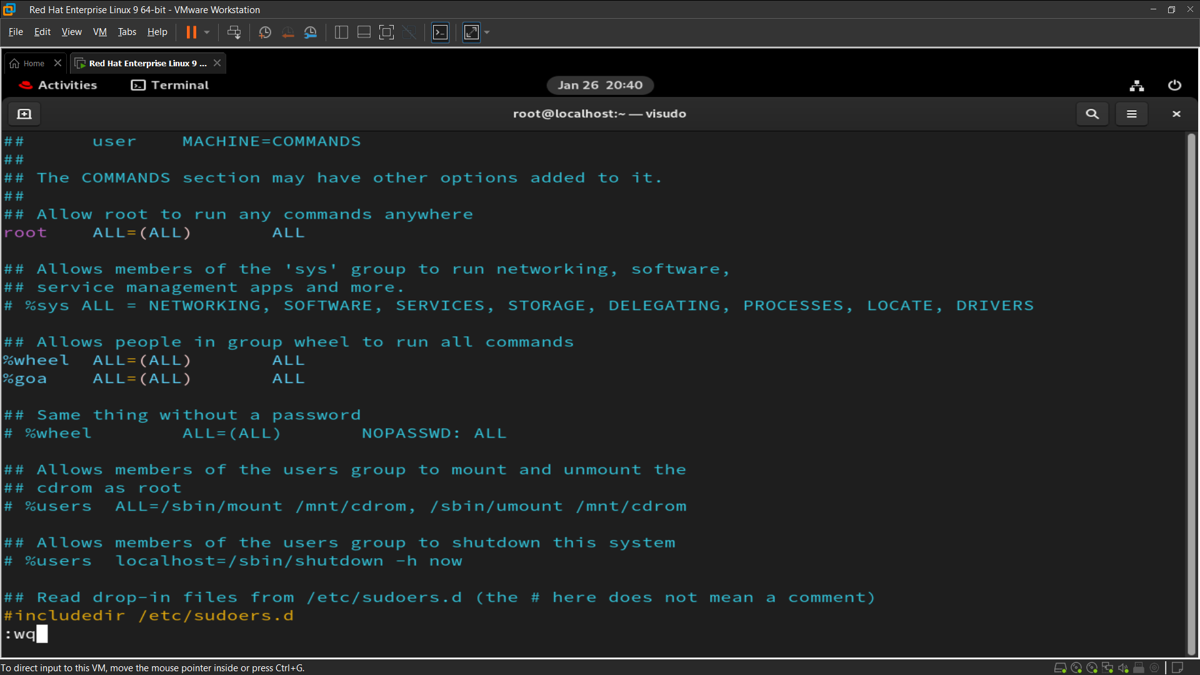

**Q13 : . How would you check all failed login attempts on the system from the last 10 days? Write the command and display the output.**

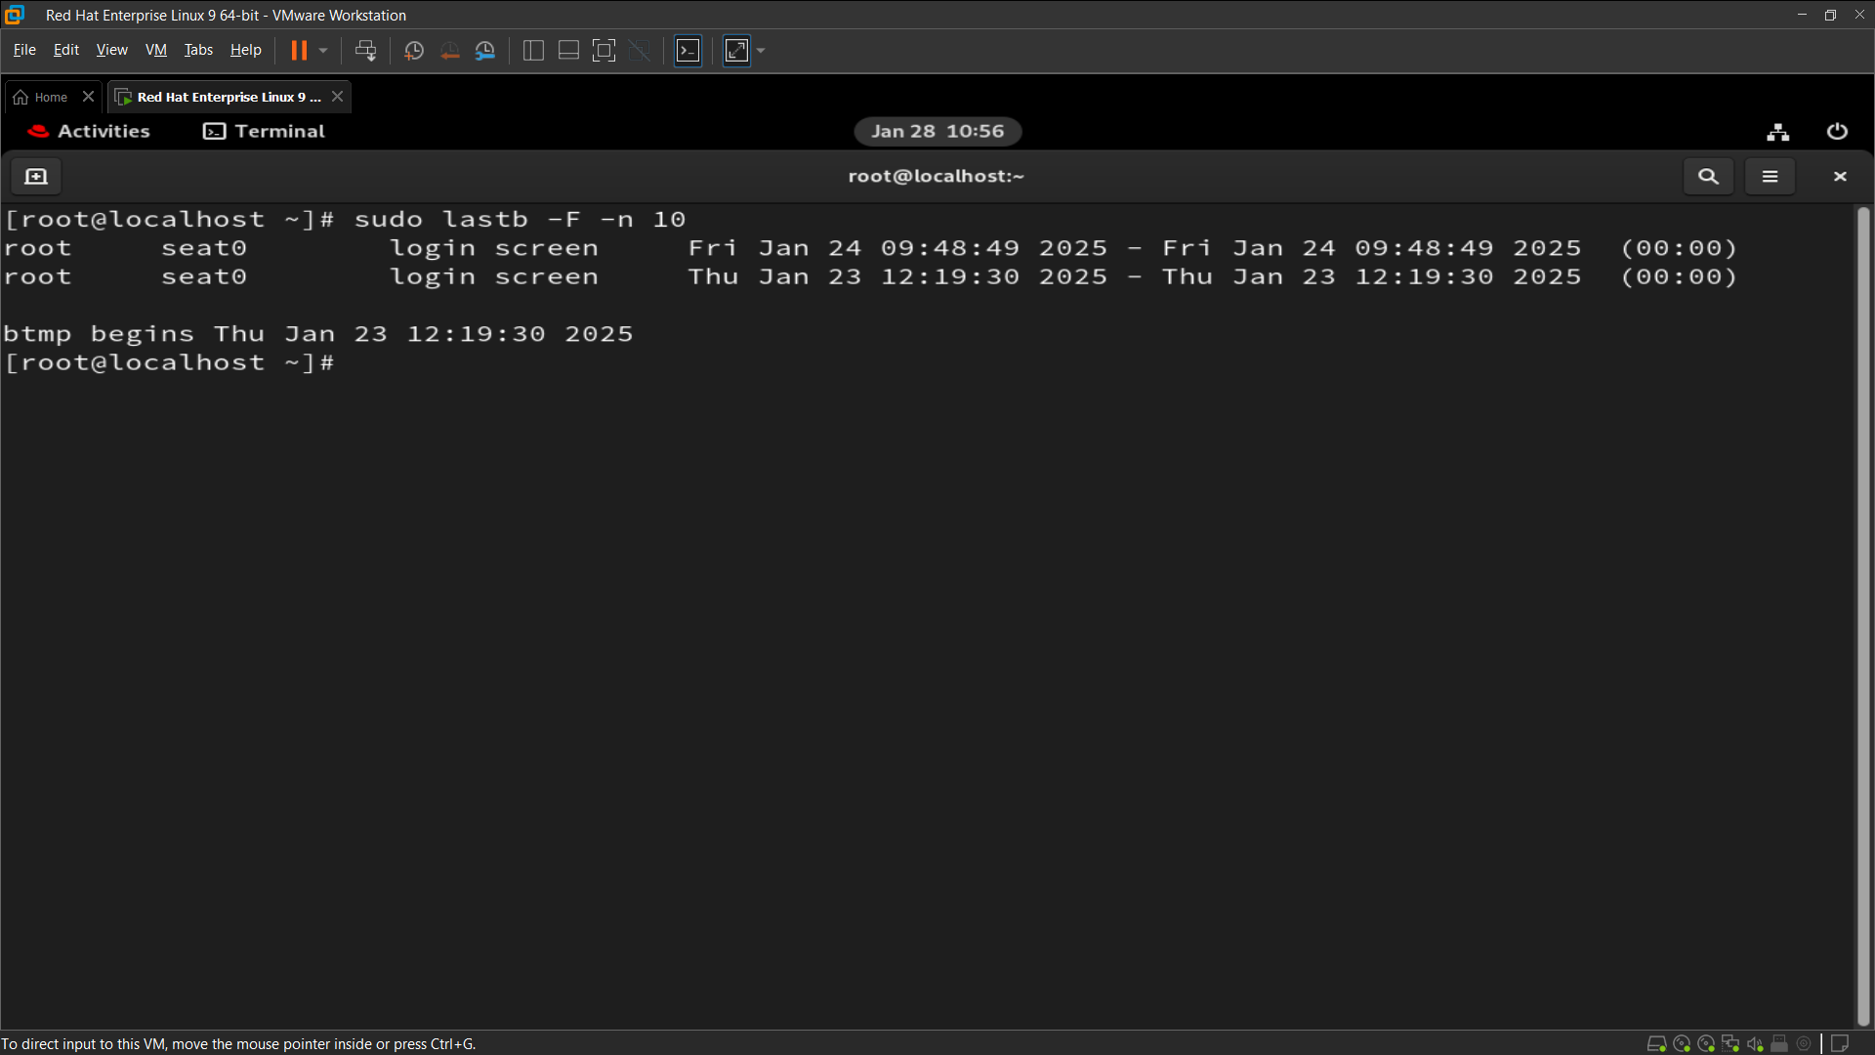

**Q14 : How would you determine how many users are currently logged into the system? Write the command to achieve this.**

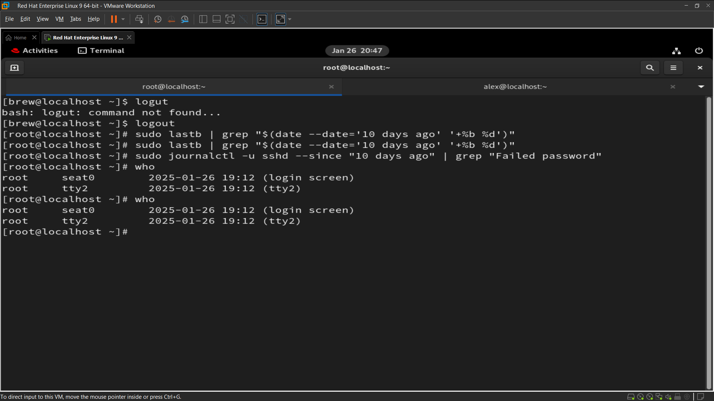

**Q15 : Add the user "sara" to the "wheel" group and create a collaborative directory /collaborative/infodir**

**IMAGE FOR Q15.**

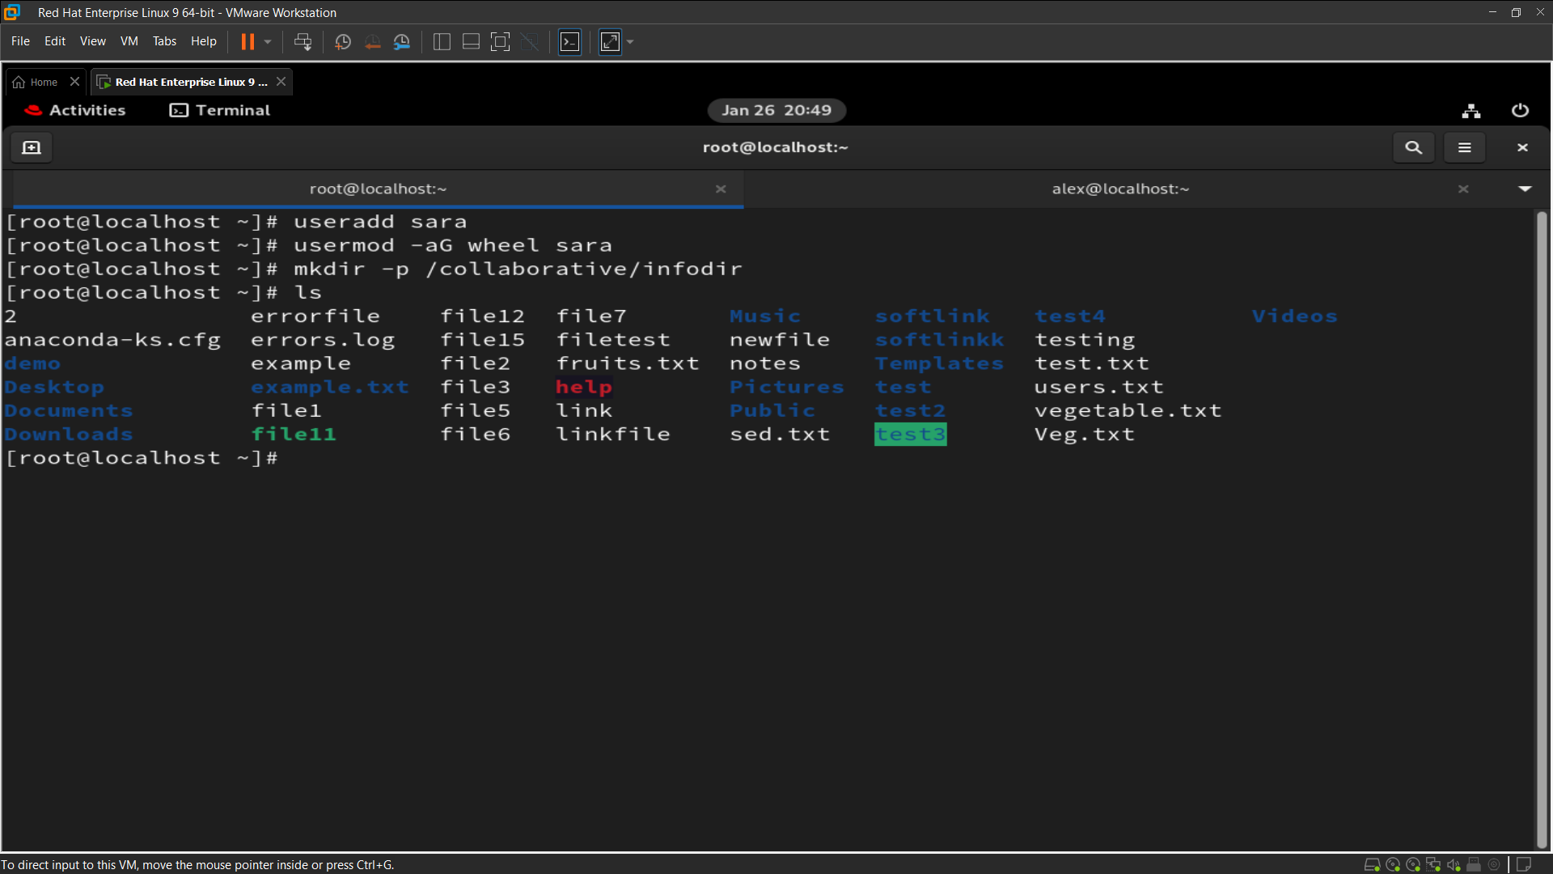

**IMAGE FOR Q15**

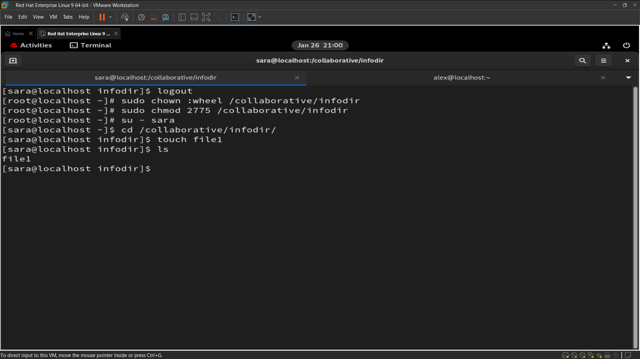

**Q16 : 16. Configure login/logout messages:**

**o When you log in with a new user, display a message: "Hello, you are logged in as USER" (where USER is replaced with the logged-in username).**

**o When you log out, display: "You are logged out now"**

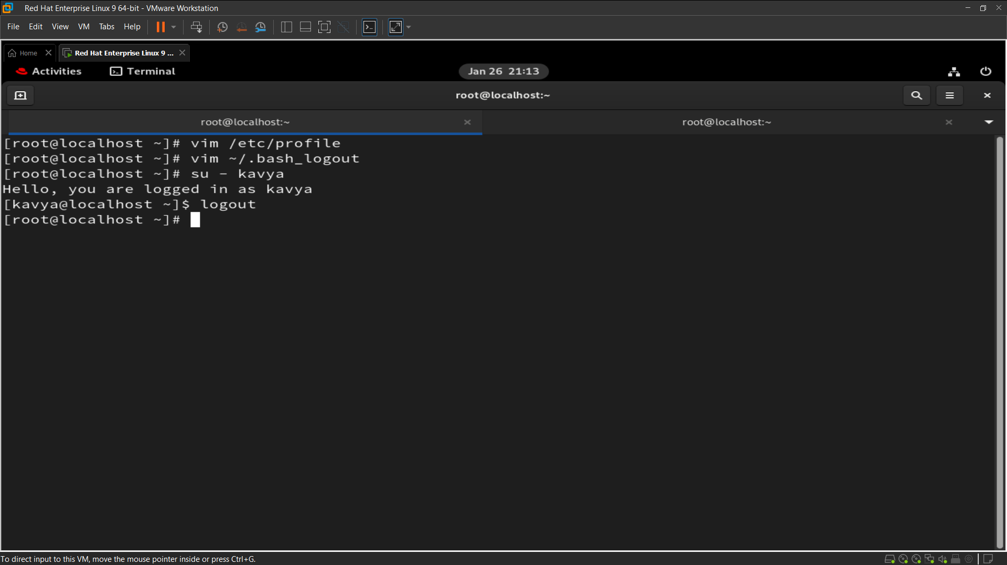

**Q18 : Create a directory /data and configure the system so that all newly created users get /data as their home directory by default**

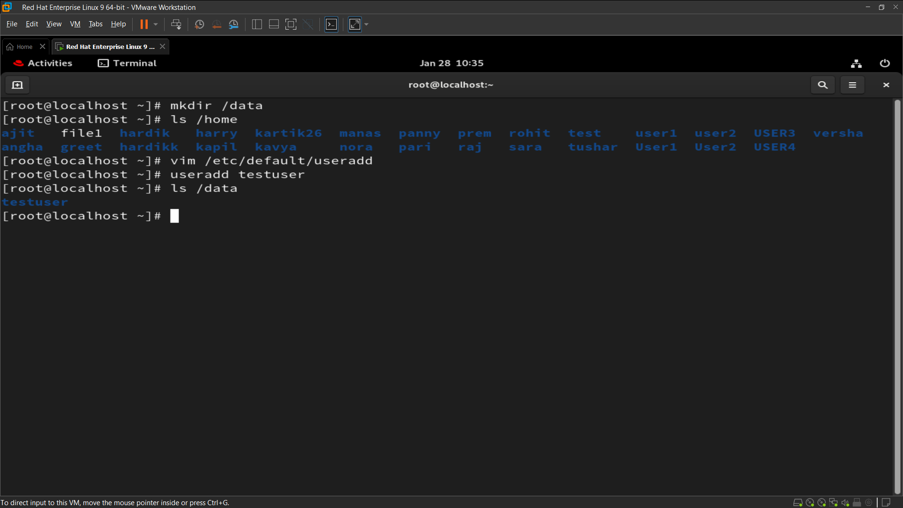

**Q19 : Name a file where we can set a file size limit upto 200 MB for a single file.**

**# vim /etc/security/limits.conf**

**# * soft fsize 204800 * hard fsize 204800**

**Q20 : Check the last three users who logged into your system.**

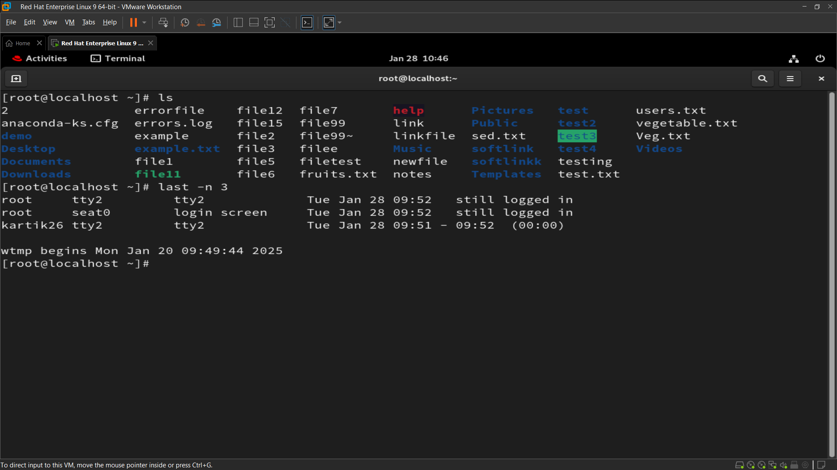

**Q21 : As a system administrator, how would you configure the system to ensure that:**

**o Automatically create an instructions.txt file in the home directory of every new user upon account creation.**

**o Ensure that the mail directory for every newly created user is set to /home/spool/mail/ by default?"**

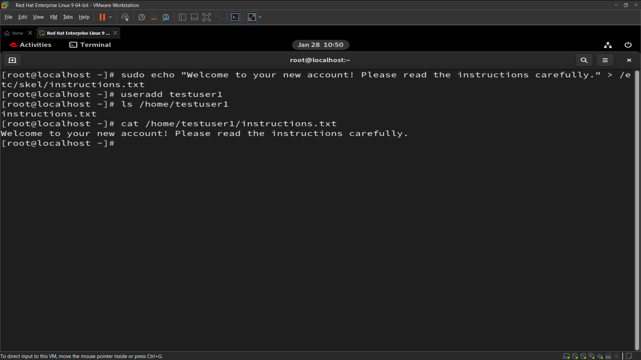

**Q22 : Delete some users o Named ‘alex’ and ‘brew’ with its all data contents including mail data.**

